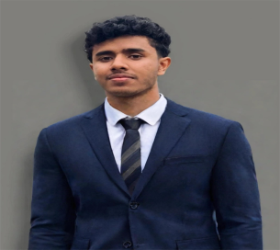MUHAMMED SHIJAS PP

## WEB DEVELOPER

BCA graduate with a keen interest in MEARN stack development . Experienced in website creation and passionate about crafting dynamic and interactive web solutions . Actively enhancing skills in html , CSS , react.js ,mongodb . Excited to leverage my education and website development experience to contribute effectively to innovate projects in tech industry .

 shijasmusthafa90@gmail.com +971 56 147 9545 Dubai, United Arab Emirates

# WORK EXPERIENCE

## Mearn stack developer intern

**Luminar Technolab**

***07/2024 – 03/2025 Kerala,India***

***Achievements***

Achieved growth in web development using html , CSS and react.js skills and been able to create responsive and stylish websites from scratch

Achieved to create websites with unique style and features using mongodb , Express, React.js and Node.js

Achieved knowledge in React with redux and Node.js with Mongodb

Developed an e-commerce website , a website to showcase media we like and to categorize them as we like and a website that helps the users to store and share our projects online

# EDUCATION

**BCA (Computer Application)**

Kannur University | Kerala , India ***2021 – 2024***

**High School Diploma(Computer Science)**

Kannur University | Kerala , India ***2019 - 2021*** **SKILLS**

**Experienced working under pressurized fast paced environments**

**Good communication and Interpersonal skills**

**Team Work**

**Strong Knowledge in reservation system -Galileo**

**Having strong problem solving skills**

**Actively listen and Quick response**

**TECHNICAL SKILLS**

*Html | CSS |React.js |Node.js | Javascript*

*MongoDB |Express.js | Bootstrap*

**PROJECTS**

* **ALAZEA ONLINE RECYCLER**

**Developed a website for an online recycler system using python, html, css, Sql .**

# MEDIA PLAYER

# Developed a website to add and categorize our favorite media such as video and music using html, css and react.js

# 

# CERTIFICATES

* **Certificate for project work done at Riss Technologies regarding a web development**
* **Certificate for completing Front end development test from Oneroadmap**
* **Certificate for completing course in MEAN/MERN full stack development from National Council for Technology and Training (NACTET)**

# 

# LANGUAGES

English Malayalam

***Full Professional Proficiency Native or Bilingual Proficiency***

Hindi Arabic

***Full Professional Proficiency Basic Working Proficiency***

# 